User Study for Resume Sandwich Application

By Joshua Hutcheson

Spring 2019

The purpose of these user studies is to define the standards and requirements of the application and further define the design goals. For the main functionality of the application, there are several general questions we expect to answer:

1. How do people feel about the general process of building a resume is for them?
2. What are some areas that people feel could be improved in some way?
3. What are some things they feel are redundant or tedious that can be simplified?
4. What are the thoughts on the initial design?

To gain an understanding of these questions, this user study implements the following methods:

1. Interview Sessions – These interview sessions will be brief and will have the goal of figuring out how a user typically makes a resume from scratch and figure out problems people address in with making resumes.
2. Card Sorting Mental Model Collection – This will provide information on how people build resumes in blocks from a cut up version of a general resume template and understand what their thought process is from the think outload method.
3. Focus Groups – This focus group of 3 participants are lead through a discussion about a set of topics, giving verbal and written feedback through discussion and exercises.
4. Low Fidelity Prototype Feedback on interface – The low fidelity prototype will focus more on the general layout of the application and participants will try to navigate through the low fidelity prototype and give feedback.

**Interview Sessions** – The interview sessions were set up one-on-one and I would interview participants about key questions to see what they thought of resume building and what their experience was. This was to gain qualitative information that could lead to insightful conclusions. These were done were face to face. Their names were not shown in the interviews, only initials to protect their identities.

**Interview 1: S (Male, 26)**

Q: What do you think is the most difficult part of building a resume?

A: For me, it is rearranging a resume to fit with what the job description I am applying for is looking for. I believe it is important to have a resume fit to the context of the application and that it needs to be tailored each time someone applies. The problem is that this takes time and careful consideration of how the position I am applying for can implement the skills I have.

Q: If there was some way you would improve the resume process, what would it be?

A: I would have a software provide 10 or 15 sentences on what the job that I am applying for is about, then have it help tailor my resume.

Q: How do you know when your resume is complete?

A: The resume is a continuous process for me. As someone who is looking for jobs and applying, I am constantly adjusting it to make sure it fits to the standards of what I am applying for. The ending is when it gets me a job.

**Interview 2: O (Female, 21)**

Q: What do you think is the most difficult part of building a resume?

A: The most difficult part for me is actually getting started with the resume. I have no idea what to do unless I look at some kind of template or where to put anything. They aren’t like writing essays as they have to be formatted in a particular way that an employer knows what I am trying to display about myself.

Q: If there was some way you would improve the resume process, what would it be?

A: I would like for someone else to do it for me (laughs). But it would at least be nice to have someone guide me along and do the formatting for me.

Q: How do you know when your resume is complete?

A: When I get it on one page and when I have a lot of stuff that is most relevant to what I am applying for.  
**Interview 3: A (Male, 33)**

Q: What do you think is the most difficult part of building a resume?

A: For me, it is not knowing the format and the fact that I have to keep changes and adjustments for the future in mind.

Q: If there was some way you would improve the resume process, what would it be?

A: I would want a way to focus on what changes need to be made based on the audience I am making it for. It would also be helpful to have a way to suggest my listed skills to a resume based on what I am applying for.

Q: How do you know when your resume is complete?

A: I don’t, I look at other peoples and see if they have something that I don’t.

**Interview 4: S (Male, 26)**

Q: What do you think is the most difficult part of building a resume?

A: I would say putting in the work experience in the format of what recruiters are looking for and finding ways to expand on work experience.

Q: If there was some way you would improve the resume process, what would it be

A: I don’t think you can to be honest. You have to do your own research to make your resume match up to what you are applying for and I’m not sure if technology is at that point yet.

Q: How do you know when your resume is complete?

A: I don’t. It’s definitely subjective and ever changing.

**Interview 5: H (Female, 20)**

Q: What do you think is the most difficult part of building a resume?

A: Starting it. Different templates tell you different ways to make them and it all gets confusing.

Q: If there was some way you would improve the resume process, what would it be?

A: Find a way to give a default format that can be applied to all kinds of job fields.

Q: How do you know when your resume is complete?

A: When it looks good enough for the position I am applying for.

**Interview: Evaluation**

After looking over the interviews, there were definitely patterns in the answers that people gave. For question 1, people thought the hardest part of building a resume was starting it or following the right kind of template. For question 2, a way of getting help building resumes using some kind of walkthrough showed up as a general response and have it suggest what skills to use. For question 3, people generally said that the resume is never done or that it is done when it fits with what they are applying for.

**Interview: Conclusions**

Some takeaways from this study is that the app should definitely focus on guiding people through building their resume. The template design should be applicable for different kinds of applications, not strictly along the lines of a particular field. Blocks on resumes should be saved so users can potentially re-use them on other resumes if they need to. Later a recommendation API can perhaps be implemented to take those values and suggest them to users based on some kind of input suggesting the king of resume they are trying to build, but that is beyond the scope of this project.

**Interview: Suggested Next Steps**

The next step will be to make sure that the interface of the application helps the user go through the resume building process step by step without having to worry about formatting. The application itself would do the formatting.

**Card Sorting Mental Model Collection** – Card Sorting typically involves having users sort a series of cards in a particular order to study their thought processes. For the context of this project, a resume template was cut up and users had to rearrange it in an order they thought would be best to put in order. The purpose of this activity was to gain insight on the general order that users believed a resume should be formatted in. Names again are not displayed. Results from this activity are displayed below:

Option 1 (7/10)

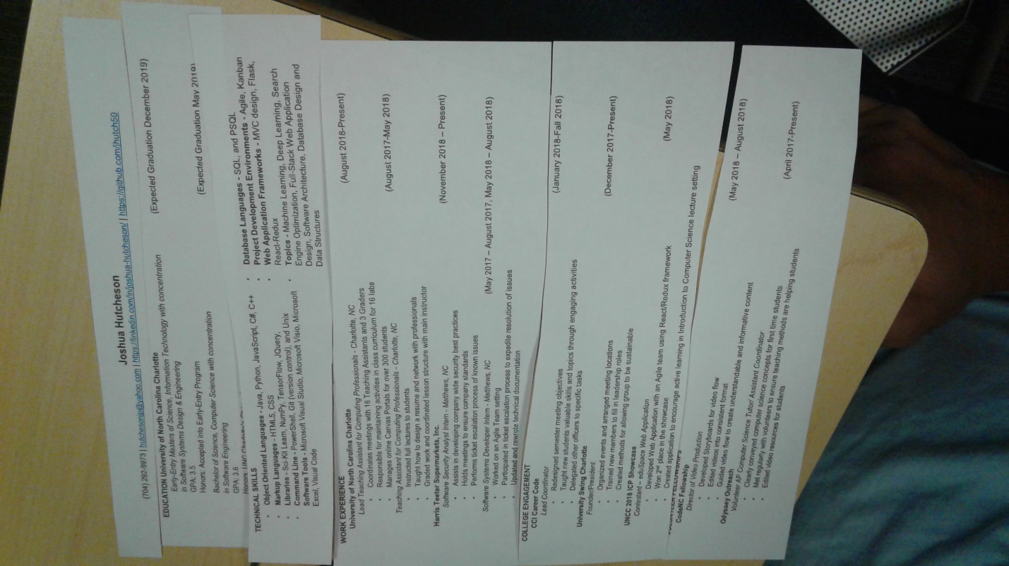

Option 2 (2/10)

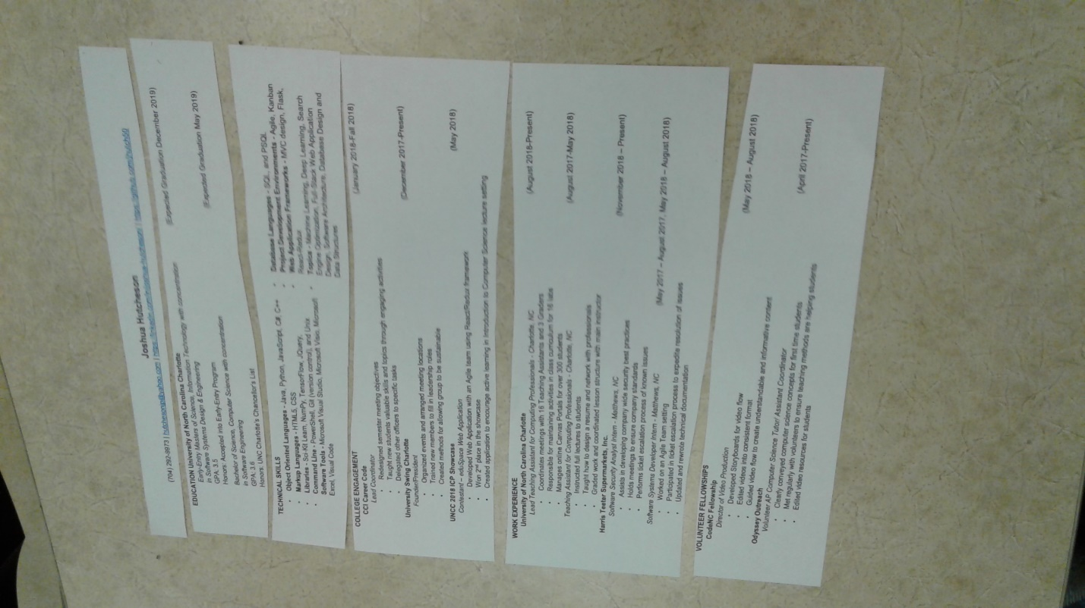

Option 3 (1/10)

Same as Option 1, only a suggestion for adding a “PROJECTS” module.

**Card Sorting: Evaluations**

Option 1 was actually the default option. Users explained that the reason they still arranged it that way was because they saw that the order of education, skills, work experience, college engagement and volunteer experience were key. With Option 2, both users who made this format suggested putting college engagement over work experience. They stated this was because they were in college and that employers had told them before that college engagement showed that they went out of their way to do things in college in addition to work and classes. Option 3 was option 1 only the user had suggested adding in a “Projects” module. Employers like to see projects, so showing descriptions of projects and what a person’s role was on the project could be helpful to the employer in uncovering more about an applicants skills.

**Card Sorting: Conclusions**

This showed users generally had the same idea on how to put together a resume, with one suggesting an additional module.

**Card Sorting: Next Steps**

Based one these results, it would be best to keep the general format flow, but also include a “PROJECTS” option.

**Focus Group –** A group of 3 people began to discuss the resume format, the same as above. They talked with one another and gave feedback. Ultimately, it proved to be the least effective of the user studies as it really only lead to an explanation of the order and answers more based on subjectivity of particular hiring managers rather than industry standards.

**Focus Group: Analysis**

L: Technical skills should definitely be on top above everything else since they typically only have 6 seconds to look at a resume. Work experience should definitely follow since it would show some experience in the workforce, followed by college engagement and volunteer.

C: Work experience should be above skills, as being employed prior shows the hiring managers

S: I heard from employers that they don’t care about volunteer experience and that you should really focus more on the work experience.

**Focus Group: Conclusions**

It appears that these answers were based more on personal opinion of particular hiring managers that the participants had spoken to rather than industry standards.

**Focus Group: Next Steps**

The main conclusion that can be drawn from this is to make the app be able to include and skip tabs in the application.

**Prototype** – Participants tried to navigate through the low fidelity prototype. There were 3 people who tested the prototype design.

**Prototype: S (Male, 26)**

**Pre-prototype -**

* Q: Have you used a resume application before? Explain.

A: No I have no used a resume application before.

* Q: Do you generally consider creating a resume to be a difficult process?

A: Yes, it is a difficult process that requires a lot of time.

**Prototype Prompts -**

* Fill out a work experience form.

Observation: User clicks on the fields and finishes by clicking the next step on the sandwich on the left.

* Export the resume to a pdf.

Observation: user exports the pdf using the pdf button.

**Post-prototype Questions**

* What do you think of the theme of the application? The theme is different and makes the application stand out from other apps that I’ve heard of.
* What did you think of the general layout of the application? The general layout is nice, I would suggest adding in arrows and a cancel button.

**Prototype: A (Female, 22)**

**Pre-prototype -**

* Have you used a resume application before? Explain. I have not.
* Do you generally consider creating a resume to be a difficult process? Yes, its time consuming.

**Prototype Questions -**

* Fill out a work experience form.

Observation: Filled out form quickly

* Export the resume to a pdf.

Observation: Exported the pdf with ease.

**Post-prototype Questions**

* What do you think of the theme of the application? The theme is funny.
* What did you think of the general layout of the application? I like it a lot. It would be nice to have the resume display on the page before exporting.

**Prototype: E (Male, 21)**

**Pre-prototype -**

* Have you used a resume application before? Explain. No I have not.
* Do you generally consider creating a resume to be a difficult process? Yes, for sure, I don’t know what to put on it.

**Prototype Questions -**

* Fill out a work experience form.

Observation: Laughed at the design and filled it out.

* Export the resume to a pdf.

Observation: Was able to accomplish the task quickly.

**Post-prototype Questions**

* What do you think of the theme of the application? It was funny and made sense for the context.
* What did you think of the general layout of the application? It was nice, but it would be nice to have an option to reset fields.

**Prototype: Analysis**

S: They stated it would have been nice to have a start screen, forward and back button rather than a navigation bar so it feels more like a process.

A: It was a good experience

E: It was enjoyable and is definitely helpful when filling out a resume.

**Prototype: Conclusions**

Overall, the responses were quite satisfied with the design of the application. It’s theme was enjoyable and was good for the context. The conclusions to draw from the prototype is that it is pleasant to navigate with but would prefer arrows and options to reset fields.

**Prototype: Next Steps**

With these, the design of the app will feature ways to navigate with arrows and find ways to reset fields.

**Overall Conclusion**

This concludes the user studies implemented into the project. From the studies observed, the initial questions proposed have essentially been answered:

1. How do people feel about the general process of building a resume is for them? The process for a lot of people is that it is hard to start, difficult to follow along with a template, and never really quite finished. An application being developed needs to keep these general thoughts in mind.
2. What are some areas that people feel could be improved in some way? Having a guided way of filling out a resume without having to deal with the formatting.
3. What are some things they feel are redundant or tedious that can be simplified? Things that can be simplified are the template design and the ability to add sections that they think are catered to a specific job.
4. What are the thoughts on the initial design? The thoughts were generally positive and were able to show a few areas for improvement in regard to the User Experience with navigation.

These ideas will be implemented into the requirements for the project in order to make it functional in these areas.